Capturas de Pantallas

Parte 1:
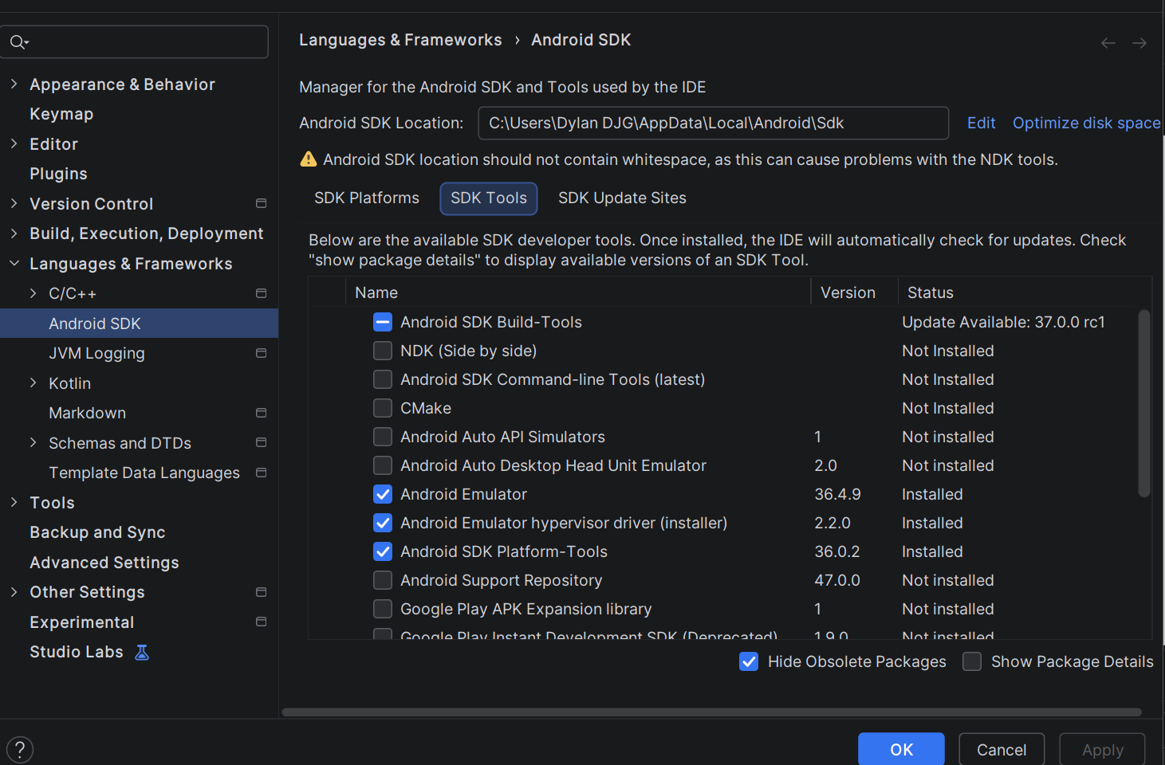
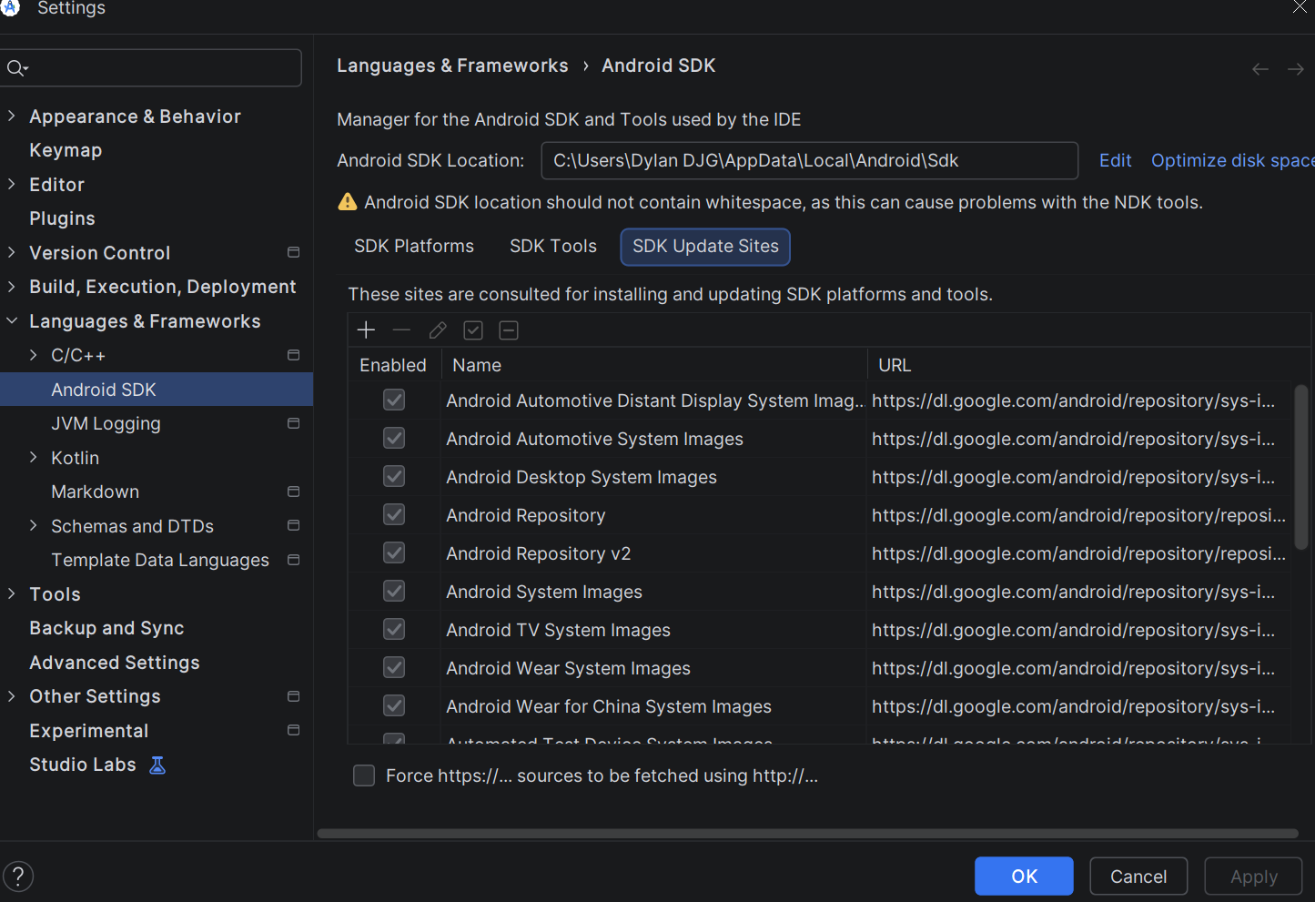

Parte 2:
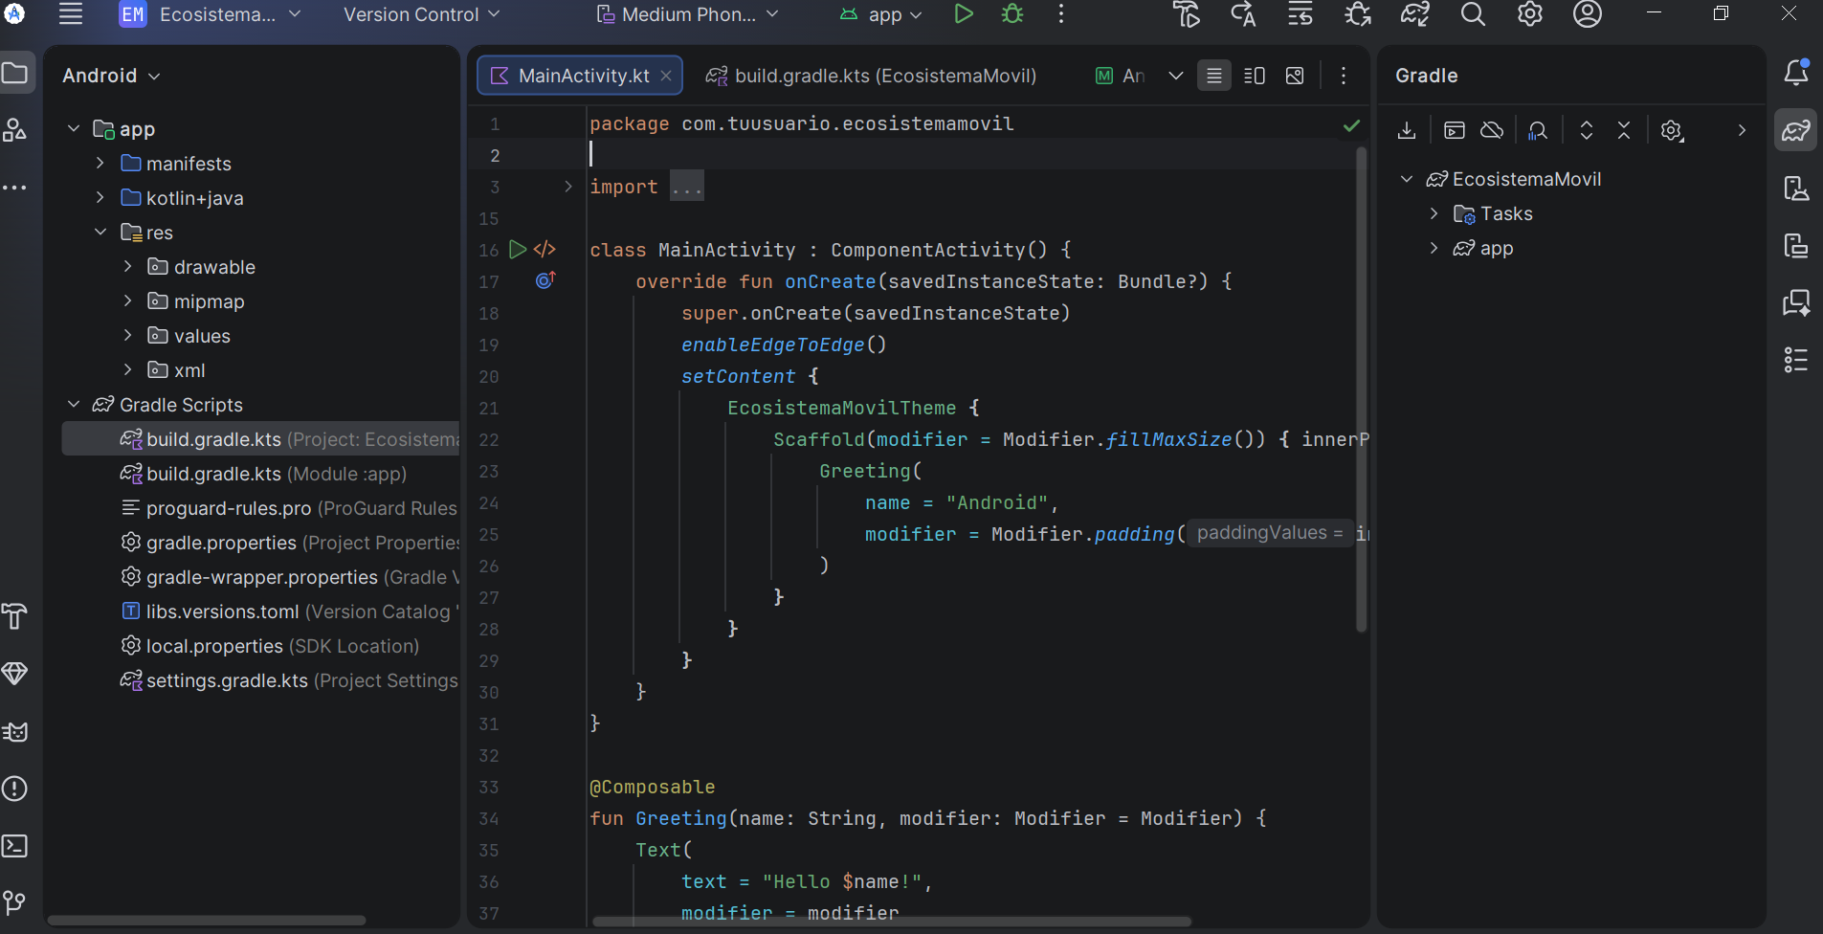
Parte 3:
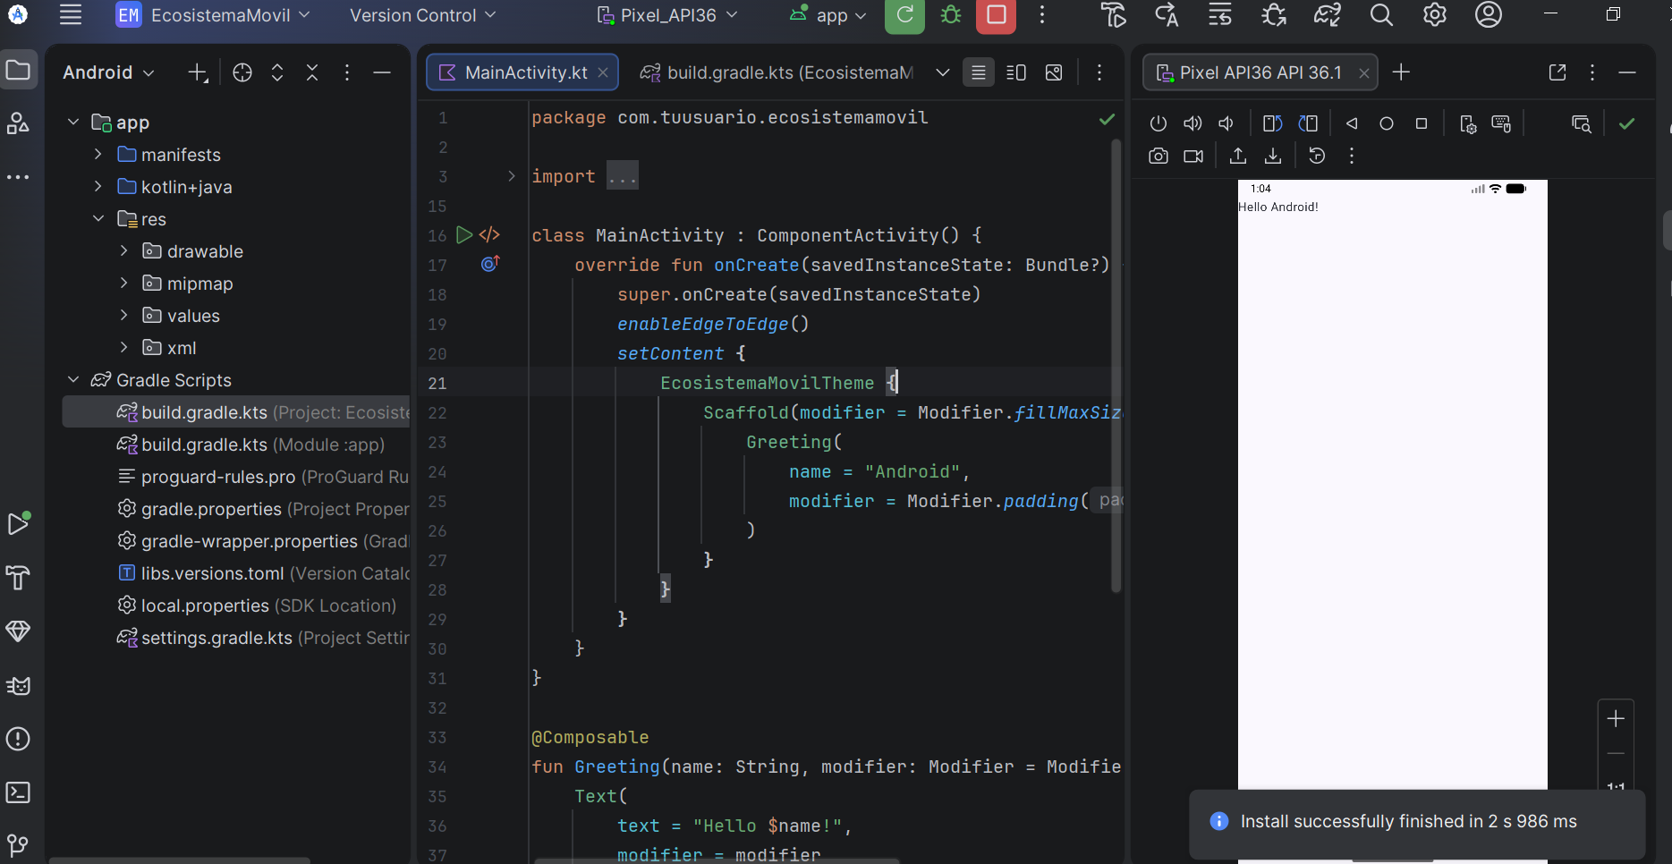
Parte 4:
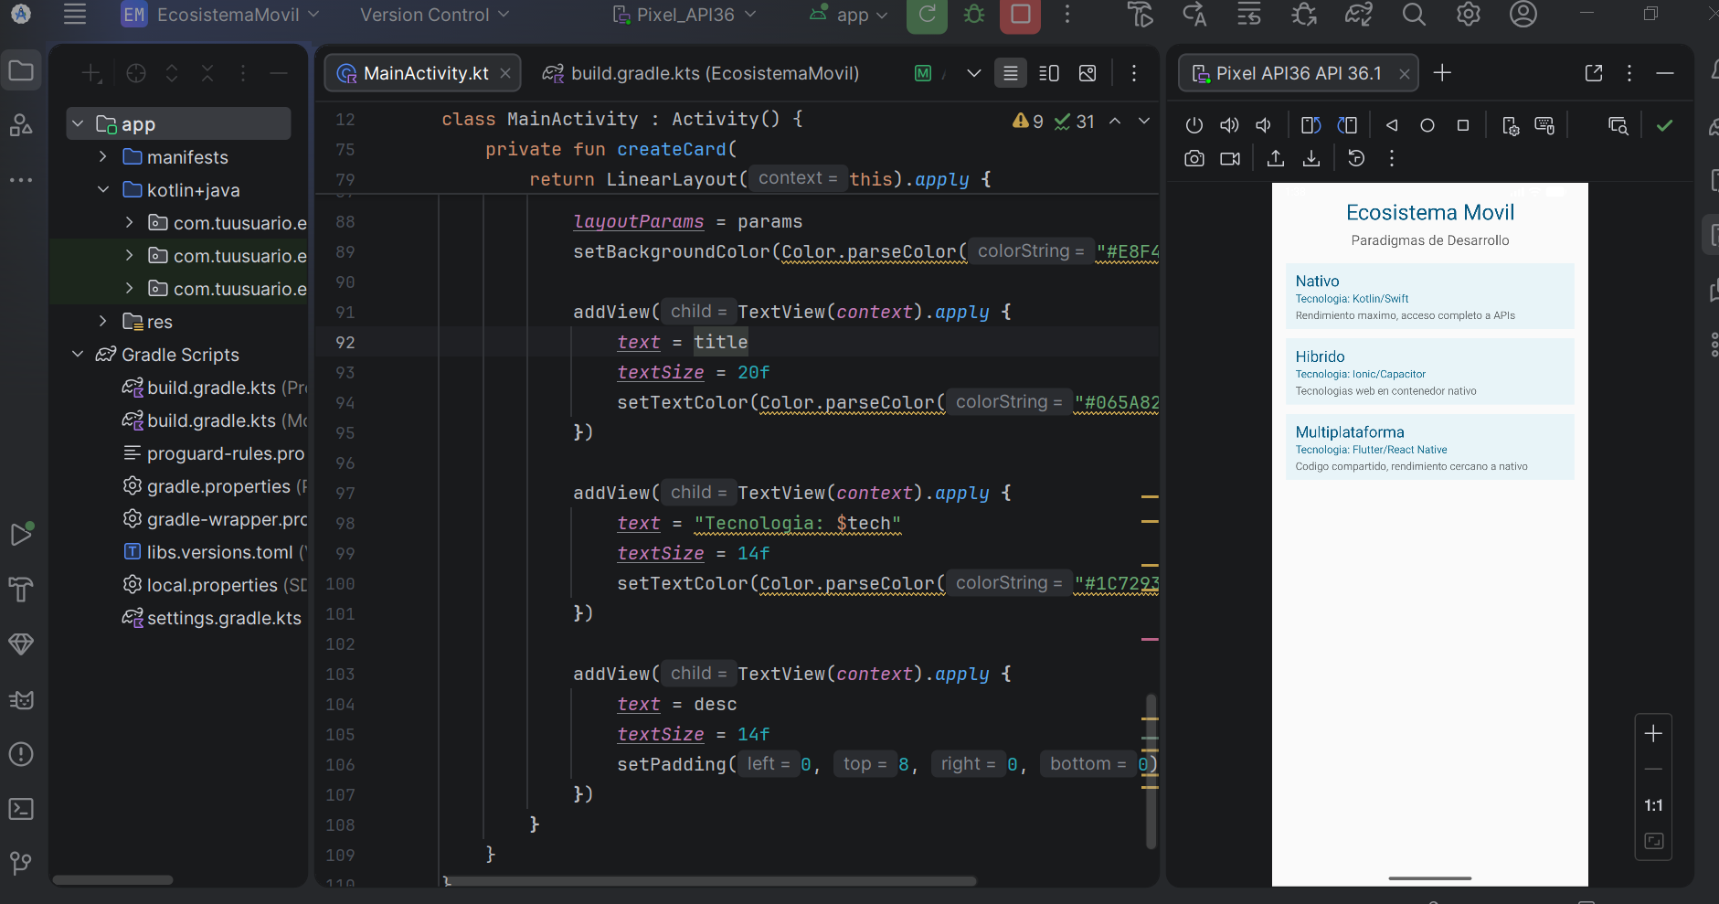
Parte 5:
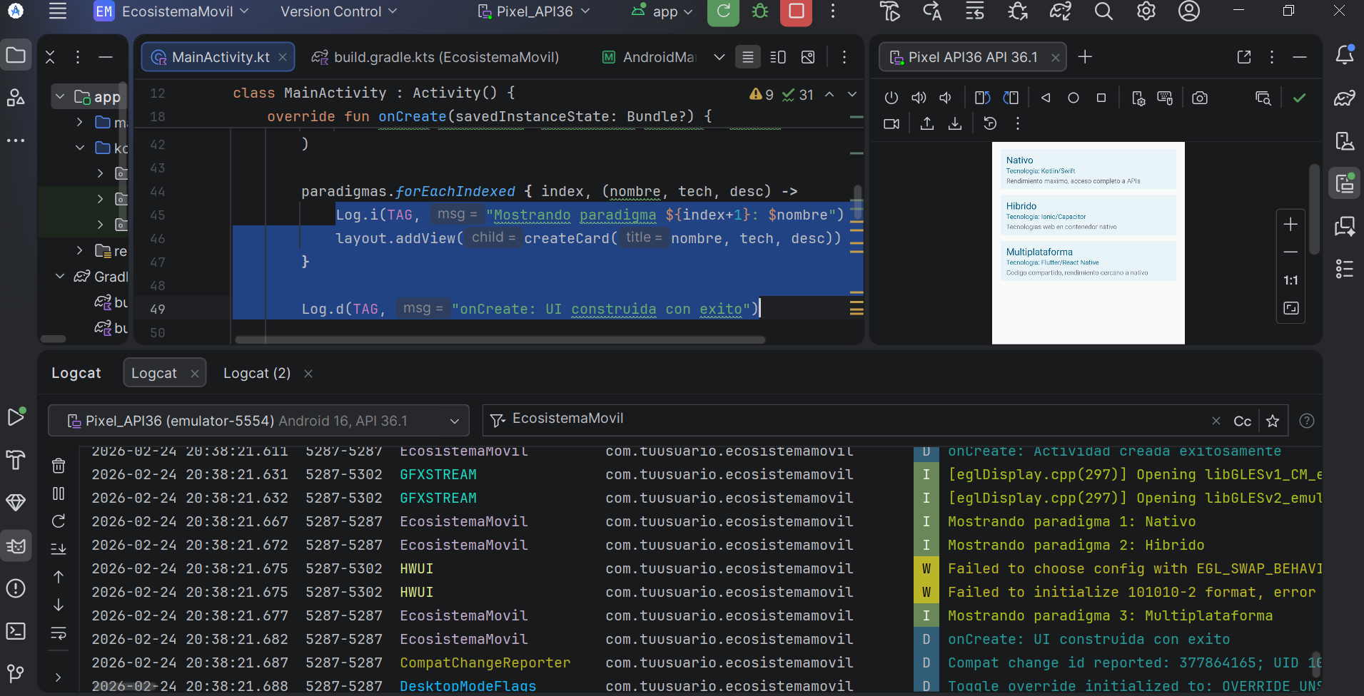

Parte 6:
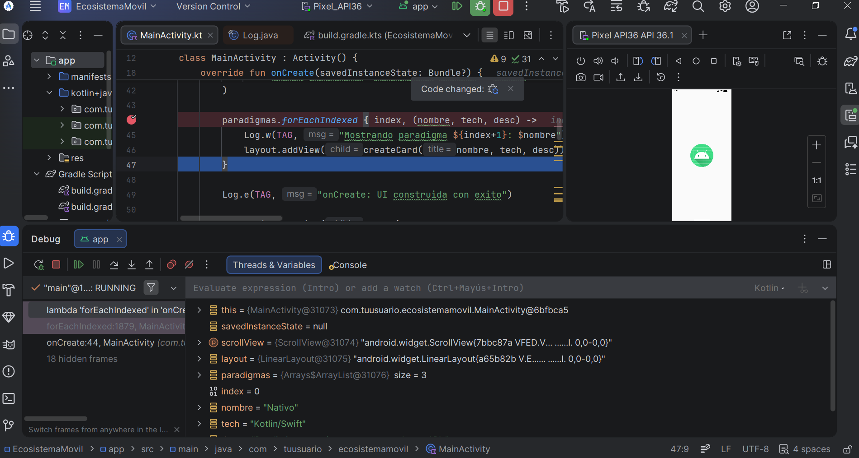
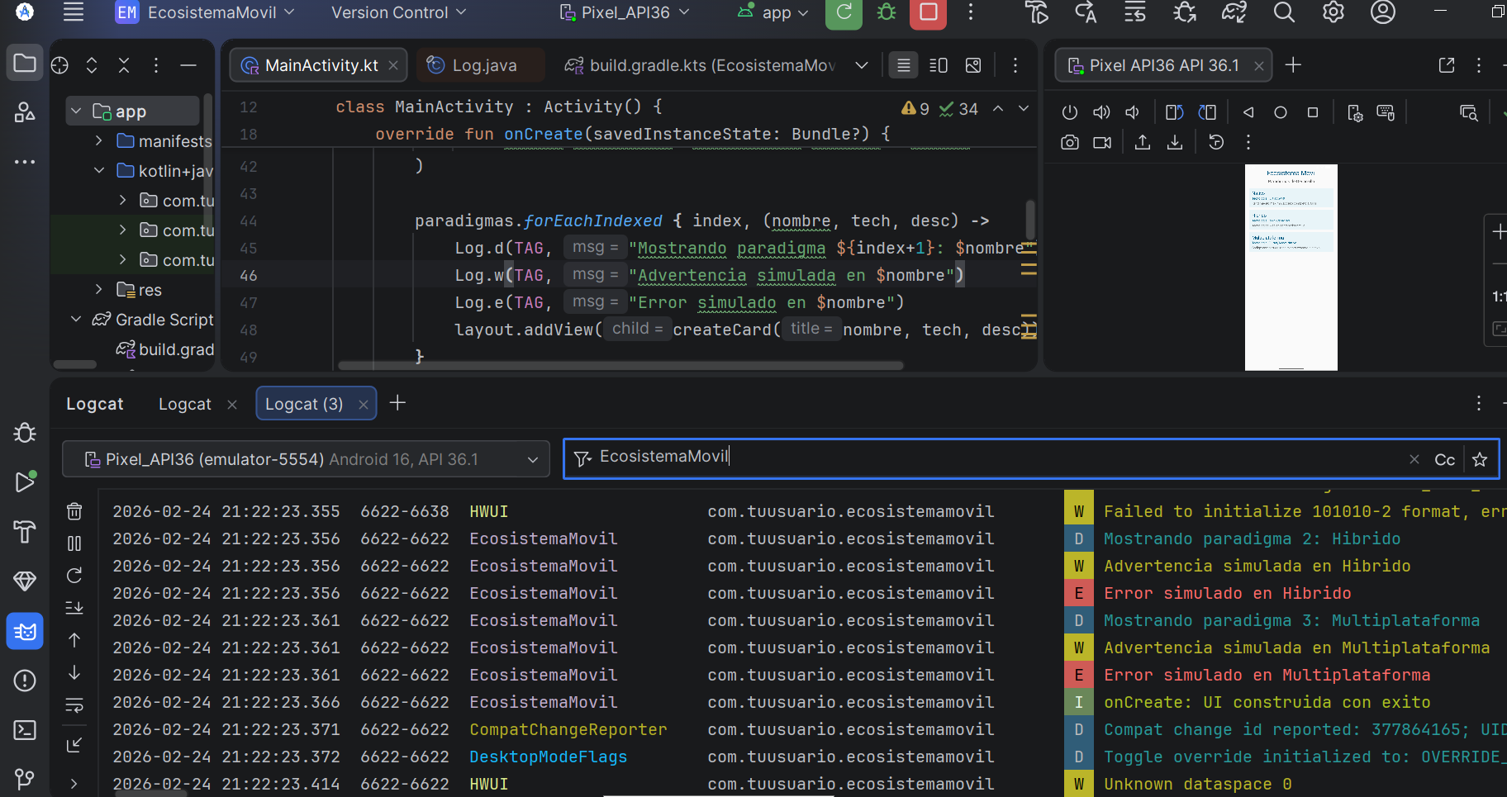

README.md
package com.tuusuario.ecosistemamovil
import android.app.Activity
import android.os.Bundle
import android.util.Log
import android.widget.TextView
import android.widget.LinearLayout
import android.widget.ScrollView
import android.graphics.Color
import android.view.Gravity
class MainActivity : Activity() {
companion object {
private const val TAG = "EcosistemaMovil"
}
override fun onCreate(savedInstanceState: Bundle?) {
super.onCreate(savedInstanceState)
Log.d(TAG, "onCreate: Actividad creada exitosamente")
val scrollView = ScrollView(this)
val layout = LinearLayout(this).apply {
orientation = LinearLayout.VERTICAL
setPadding(48, 48, 48, 48)
}
// Título principal
layout.addView(createTitle("Ecosistema Movil"))
layout.addView(createSubtitle("Paradigmas de Desarrollo"))
// Paradigmas
val paradigmas = listOf(
Triple("Nativo", "Kotlin/Swift",
"Rendimiento maximo, acceso completo a APIs"),
Triple("Hibrido", "Ionic/Capacitor",
"Tecnologias web en contenedor nativo"),
Triple("Multiplataforma", "Flutter/React Native",
"Codigo compartido, rendimiento cercano a nativo")
)
paradigmas.forEachIndexed { index, (nombre, tech, desc) ->
Log.d(TAG, "Mostrando paradigma ${index+1}: $nombre")
Log.w(TAG, "Advertencia simulada en $nombre")
Log.e(TAG, "Error simulado en $nombre")
layout.addView(createCard(nombre, tech, desc))
}
Log.i(TAG, "onCreate: UI construida con exito")
scrollView.addView(layout)
setContentView(scrollView)
}
private fun createTitle(text: String): TextView {
return TextView(this).apply {
this.text = text
textSize = 28f
setTextColor(Color.parseColor("#065A82"))
gravity = Gravity.CENTER
setPadding(0, 0, 0, 16)
}
}
private fun createSubtitle(text: String): TextView {
return TextView(this).apply {
this.text = text
textSize = 18f
setTextColor(Color.parseColor("#666666"))
gravity = Gravity.CENTER
setPadding(0, 0, 0, 32)
}
}
private fun createCard(
title: String, tech: String, desc: String
): LinearLayout {
return LinearLayout(this).apply {
orientation = LinearLayout.VERTICAL
setPadding(32, 24, 32, 24)
val params = LinearLayout.LayoutParams(
LinearLayout.LayoutParams.MATCH_PARENT,
LinearLayout.LayoutParams.WRAP_CONTENT
).apply { setMargins(0, 16, 0, 16) }
layoutParams = params
setBackgroundColor(Color.parseColor("#E8F4F8"))
addView(TextView(context).apply {
text = title
textSize = 20f
setTextColor(Color.parseColor("#065A82"))
})
addView(TextView(context).apply {
text = "Tecnologia: $tech"
textSize = 14f
setTextColor(Color.parseColor("#1C7293"))
})
addView(TextView(context).apply {
text = desc
textSize = 14f
setPadding(0, 8, 0, 0)
})
}
}
}

